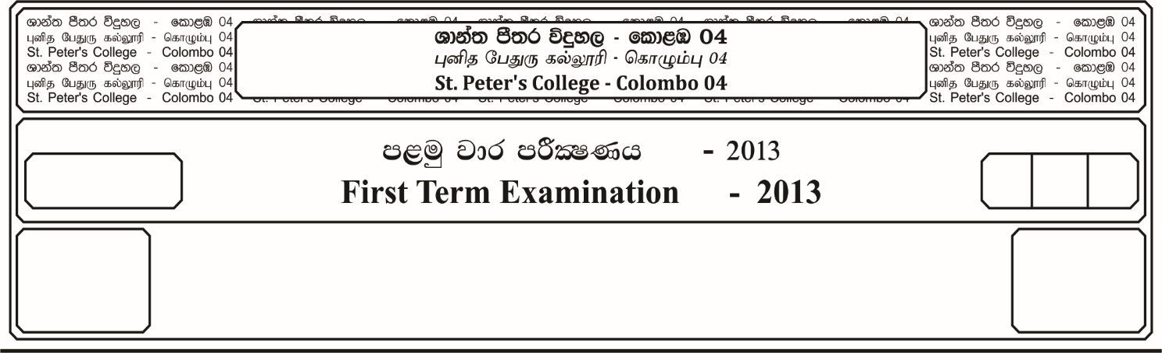

12 fY%aKsh

GRADE 12

E

$2_{2 }^{1}$ meh

$2_{2}^{1}$ Hour

I

**f;jk jdr mÍCIKh - 2022**

**Third Term Examination - 2022**

ixhqla; .Ks;h - ¸

**COMBINED MATHEMATICS – I**

10

* **Answer all the questions of Part A and any four questions of Part B.**

**Part -A**

01. If and are the roots of the equation $x^{2}$ $- 4x+1=0$ Prove that .

02. Resolve into partial fractions,

03. Solve the equation,

04. If Prove that

05. Prove that,

06. If the following points are collinear, Find the value of ***K***.

$\left(2, 3\right) , \left(K,6\right) and \left(3, 2\right)$

07.If $x$ is real, show that the expression $\frac{x^{2} + x + 1}{x + 1}$ cannot have a real value

between and 1.

08. The curve $y=x^{2}+ax+b$ has a turning Point at $(1, 3)$. Find the values of ***a*** and ***b***.

**Part – B**

* **Answer four questions only.**

09. a). Find the set of Values of ***k*** for which the equation.

$\left(2k-1\right)x^{2}+\left(2k+1\right)x + \left(k+1\right)=0$ has real roots.

Given that the sum of the roots of the above is 7, find ***k***, and hence or otherwise the product of these roots.

b). State the remainder theorem of a polynomial. If $f\left(x\right)$ is a polynomial of degree two. When $f\left(x\right)$ is divided by $\left(x-1\right), x$ and $\left(x+1\right)$ the remainders are 0, 1 and 5 respectively Find

10. a). Obtain partial fractions for the following expressions.

i. $\frac{x^{3}}{\left(x+1\right) (x+2)}$ ii) $\frac{3x+2}{{\left(3x-1\right)}^{2}}$

b). Solve the following inequalities,

i. $2x>$ $\frac{1}{x}$ ii) $\frac{1}{x-1} ≥\frac{x}{3-x}$

(c) If a and b are two positive numbers then prove that,

$\frac{a+b}{2}$ $≥\sqrt{ab}$

Given that a + b = 1, show that,

11. a). i. Differentiate with respect to ***x***,

$y=$ l $n$ $\left(\frac{2 + cosx}{3 - sinx}\right)$

ii. If $x=sint$ and y = cos 2t then prove that,

$\frac{d^{2}y}{dx^{2}}+4=0$

b). A square piece of board of side 18 cm is to be made into a box without a top by cutting a square from each corner and folding the flaps. What should be the side of the square to be cut off, so that the volume of the box is maximum.

12. a). Prove that $\frac{\operatorname{Cot}{A+CosecA - 1}}{CotA-Cosec A + 1}= \frac{1+cosA}{\sin{A}}$

b). If ABC is a triangle, Prove that

$SinA+SinB-SinC=4Sin$ $\frac{A}{2}$ $Sin$ $\frac{B}{2}$ $Cos$ $\frac{C}{2}$

c). State the sine rule and the cosine. Rule of the triangle ABC. With a usual notation in a triangle ABC, Prove that,

13. a). Find the general solution of the equation,

$Sinθ-Cosθ=- \sqrt{2}$

b). Prove that, ${Cos}^{-1}\frac{4}{5}+Cos^{-1}\frac{12}{13}=Cos^{-1}$ $\left(\frac{33}{65}\right)$

c). Solve for *x,*

i.

ii.

14. The points $A(-4, 6)$ and $C\left(-1, 1\right)$ are opposite vertices of a parallelgram ABCD. The sides BC, CD of the parallelgram lie along the lines $x+3y-2=0$ and $x-y+2=0$ respectively.

i). Show that, co-ordinates of D is (2, 4)

ii). Show that, the tangent of the acute angle between the diagonals of the Parallelogram is $\frac{24}{11}$.

iii). Find the length of the perpendicular from A to the side CD.

iv). The area of the parallelcgram is 24 square units.